**Лабораторна робота № 5**

Проектування архітектури баз даних із застосуванням засобів моделювання та реверсного інжинірингу

# **Screenshots**

## **Model C:\Users\User\Desktop\Project_5\22.jpg**

## **Structure**

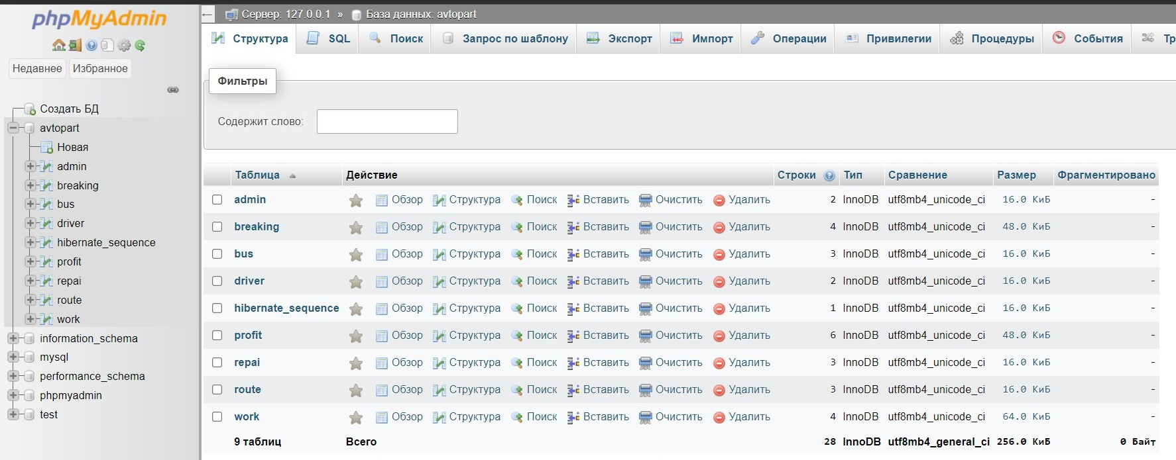

### **Admin Table**

**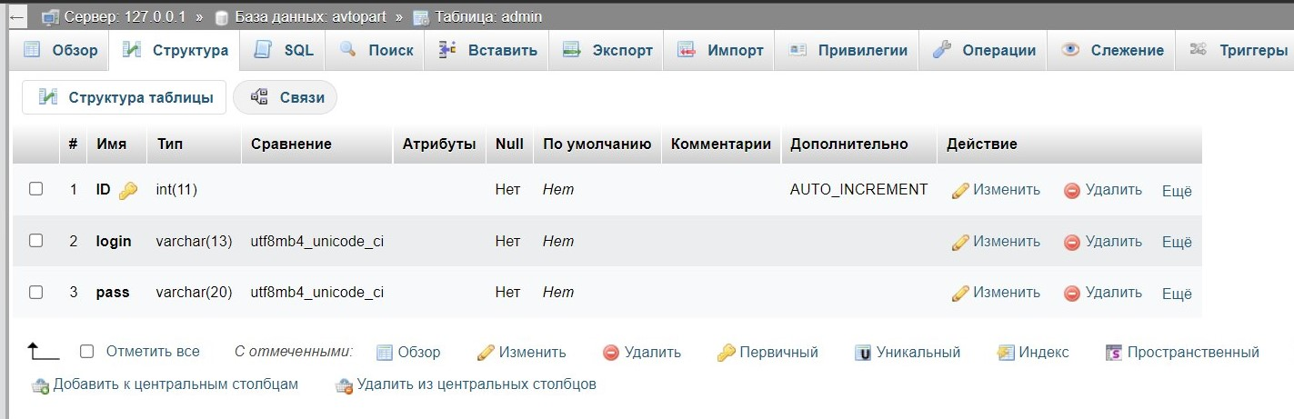**

### **Breaking Table**

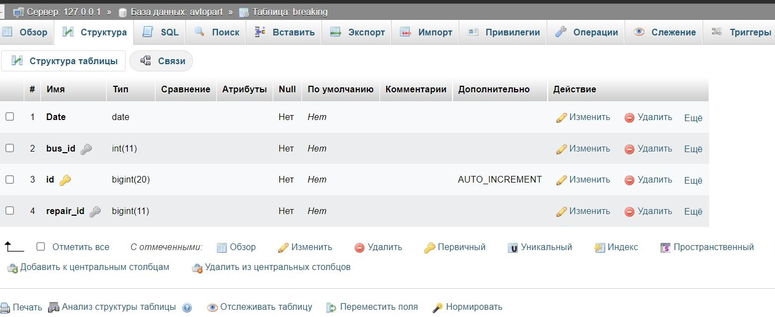

### **Bus**

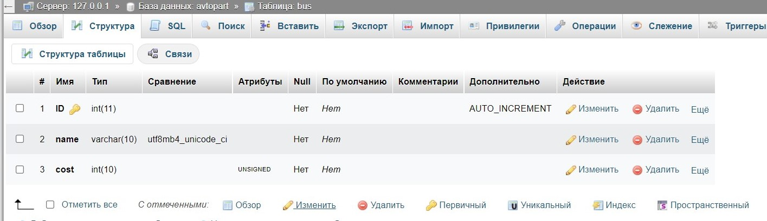

### **Driver**

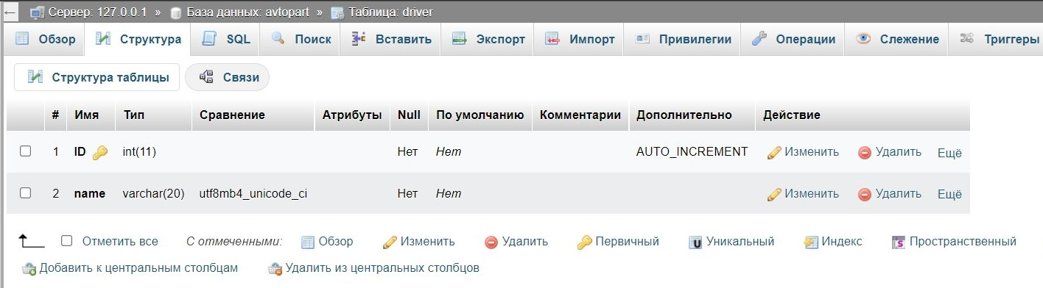

### **Hibernate\_sequence**

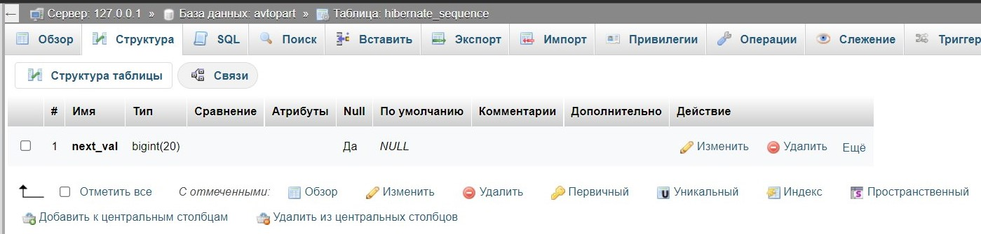

### **Profit**

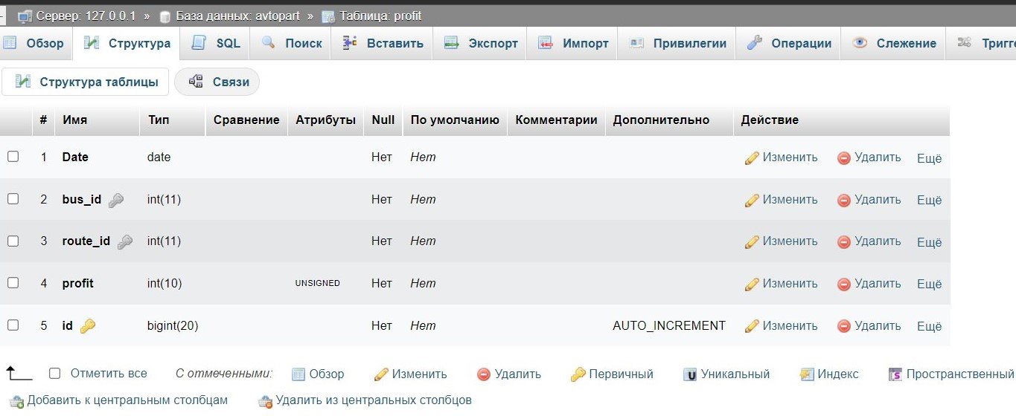

### **Repair**

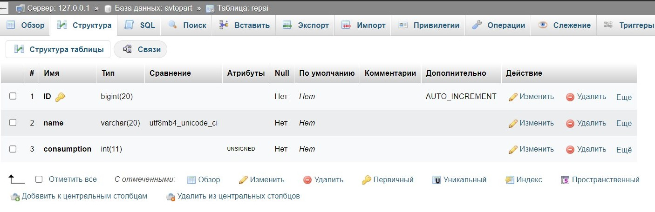

### **Route**

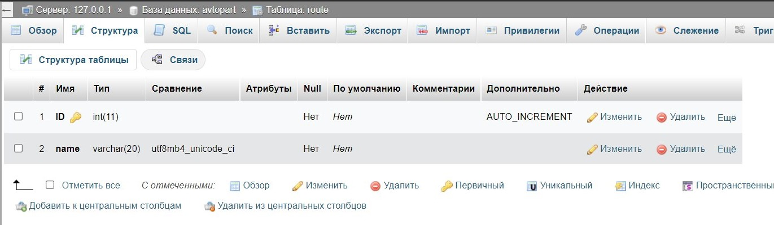

### **Work**

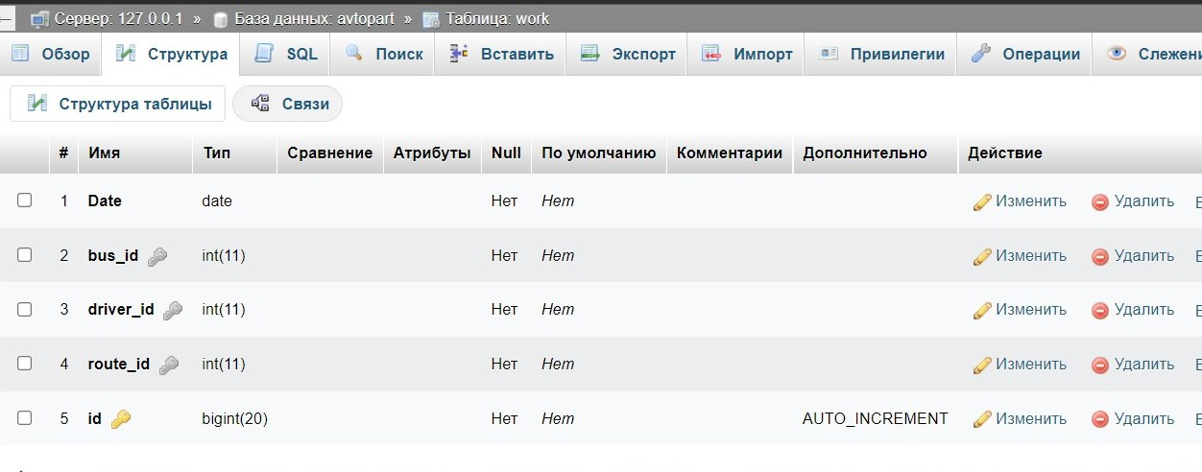

## **Test Data**

### **Admin Table**

**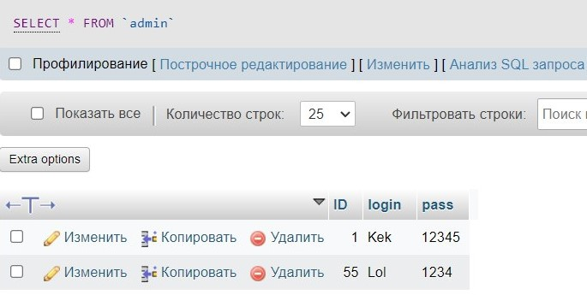**

### **Breaking Table**

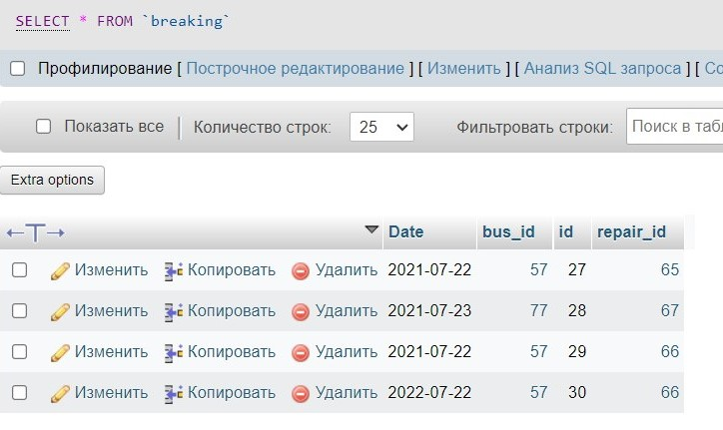

### **Bus**

**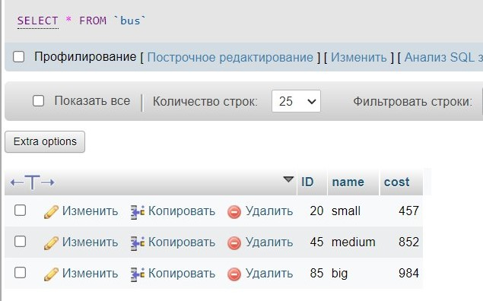**

### **Driver**

**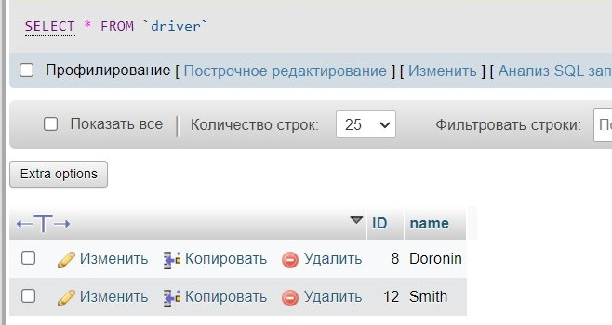**

### **Hibernate\_sequence**

**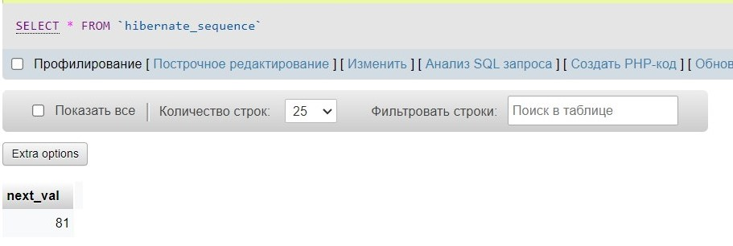**

### **Profit**

**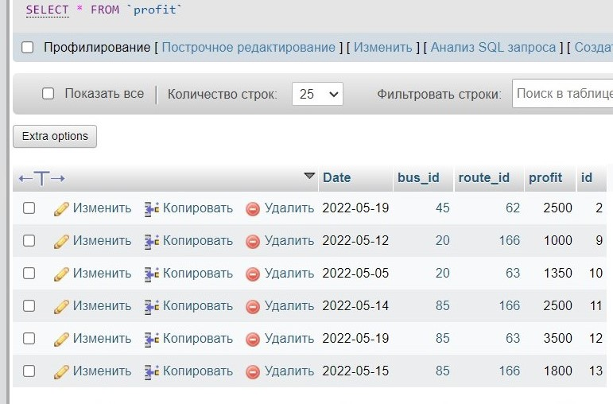**

### **Repair**

**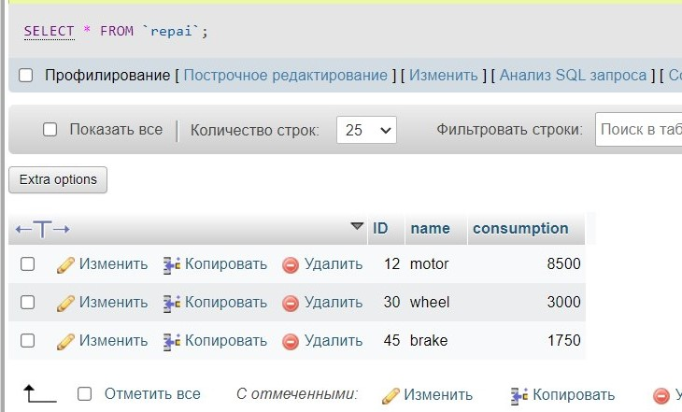**

### **Route**

**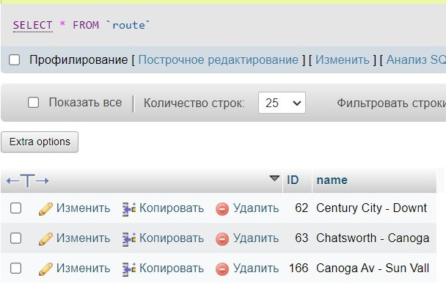**

### **Work**

**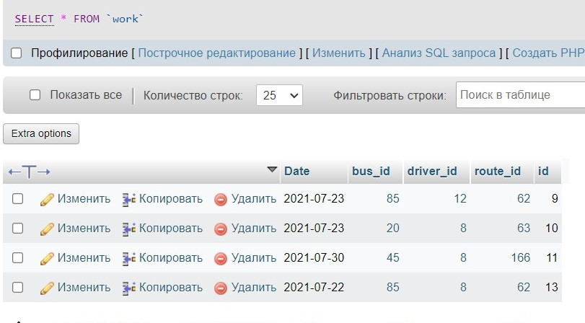**

## **Commands**

### **Select**

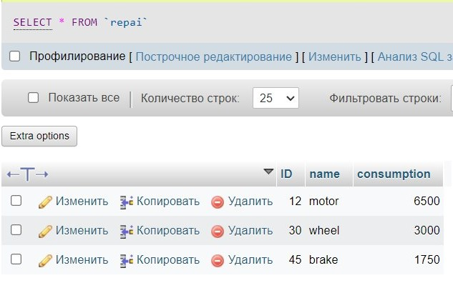

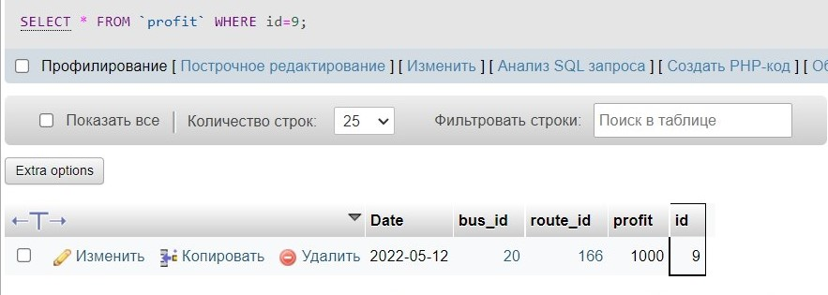

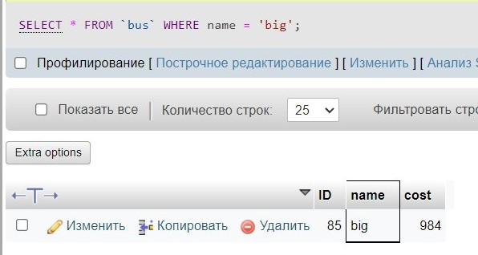

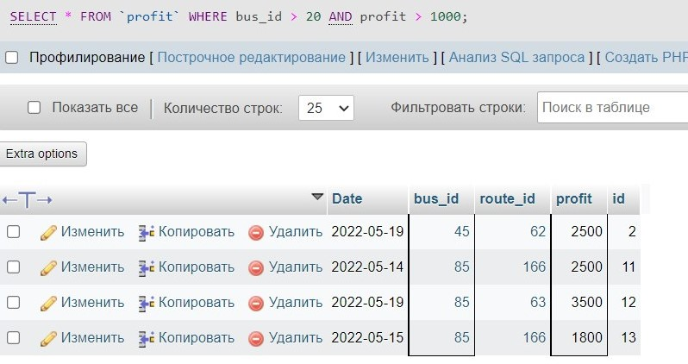

### **Insert**

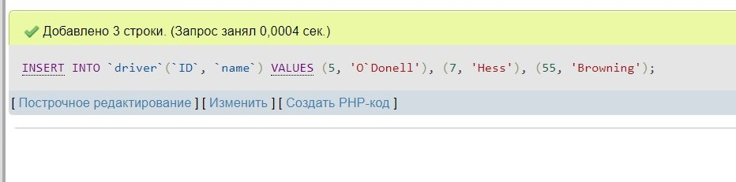

### **Update**

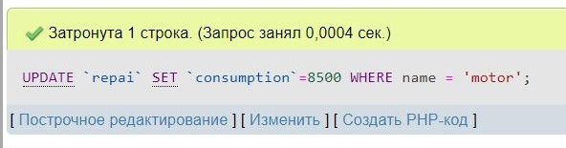

### **Delete**

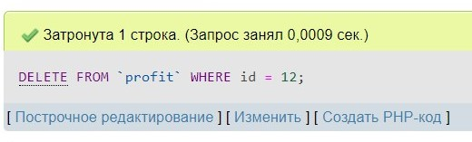

# **Script**

-- phpMyAdmin SQL Dump  
-- version 5.2.0  
-- https://www.phpmyadmin.net/  
--  
-- Хост: 127.0.0.1  
-- Время создания: Май 19 2022 г., 05:27  
-- Версия сервера: 10.4.24-MariaDB  
-- Версия PHP: 8.1.6  
  
SET SQL\_MODE = "NO\_AUTO\_VALUE\_ON\_ZERO";  
START TRANSACTION;  
SET time\_zone = "+00:00";  
  
  
/\*!40101 SET @OLD\_CHARACTER\_SET\_CLIENT = @@CHARACTER\_SET\_CLIENT \*/;  
/\*!40101 SET @OLD\_CHARACTER\_SET\_RESULTS = @@CHARACTER\_SET\_RESULTS \*/;  
/\*!40101 SET @OLD\_COLLATION\_CONNECTION = @@COLLATION\_CONNECTION \*/;  
/\*!40101 SET NAMES utf8mb4 \*/;  
  
--  
-- Data Base: `avtopark`  
--  
CREATE DATABASE IF NOT EXISTS `avtopark` DEFAULT CHARACTER SET utf8mb4 COLLATE utf8mb4\_general\_ci;  
USE `avtopark`;  
  
-- --------------------------------------------------------  
  
--  
-- Table structure for table `admin`  
--  
  
DROP TABLE IF EXISTS `admin`;  
CREATE TABLE `admin`  
(  
 `ID` int(11) NOT NULL,  
 `login` varchar(13) COLLATE utf8mb4\_unicode\_ci NOT NULL,  
 `pass` varchar(20) COLLATE utf8mb4\_unicode\_ci NOT NULL  
) ENGINE = InnoDB  
 DEFAULT CHARSET = utf8mb4  
 COLLATE = utf8mb4\_unicode\_ci;  
  
--  
-- Dumping data for table `admin`  
--  
  
INSERT INTO `admin` (`ID`, `login`, `pass`)  
VALUES (1, 'Kek', '12345'),  
 (55, 'Lol', '1234');  
  
-- --------------------------------------------------------  
  
--  
-- Table structure for table `breaking`  
--  
  
DROP TABLE IF EXISTS `breaking`;  
CREATE TABLE `breaking`  
(  
 `Date` date NOT NULL,  
 `bus\_id` int(11) NOT NULL,  
 `id` bigint(20) NOT NULL,  
 `repair\_id` bigint(11) NOT NULL  
) ENGINE = InnoDB  
 DEFAULT CHARSET = utf8mb4  
 COLLATE = utf8mb4\_unicode\_ci;  
  
--  
-- Dumping data for table `breaking`  
--  
  
INSERT INTO `breaking` (`Date`, `bus\_id`, `id`, `repair\_id`)  
VALUES ('2021-07-22', 20, 27, 45),  
 ('2021-07-23', 85, 28, 30),  
 ('2021-07-22', 20, 29, 12),  
 ('2022-07-22', 20, 30, 12);  
  
-- --------------------------------------------------------  
  
--  
-- Table structure for table `bus`  
--  
  
DROP TABLE IF EXISTS `bus`;  
CREATE TABLE `bus`  
(  
 `ID` int(11) NOT NULL,  
 `name` varchar(10) COLLATE utf8mb4\_unicode\_ci NOT NULL,  
 `cost` int(10) UNSIGNED NOT NULL  
) ENGINE = InnoDB  
 DEFAULT CHARSET = utf8mb4  
 COLLATE = utf8mb4\_unicode\_ci;  
  
--  
-- Dumping data for table `bus`  
--  
  
INSERT INTO `bus` (`ID`, `name`, `cost`)  
VALUES (20, 'small', 457),  
 (45, 'medium', 852),  
 (85, 'big', 984);  
  
-- --------------------------------------------------------  
  
--  
-- Table structure for table `driver`  
--  
  
DROP TABLE IF EXISTS `driver`;  
CREATE TABLE `driver`  
(  
 `ID` int(11) NOT NULL,  
 `name` varchar(20) COLLATE utf8mb4\_unicode\_ci NOT NULL  
) ENGINE = InnoDB  
 DEFAULT CHARSET = utf8mb4  
 COLLATE = utf8mb4\_unicode\_ci;  
  
--  
-- Dumping data for table `driver`  
--  
  
INSERT INTO `driver` (`ID`, `name`)  
VALUES (5, 'O`Donell'),  
 (7, 'Hess'),  
 (8, 'Doronin'),  
 (12, 'Smith'),  
 (55, 'Browning');  
  
-- --------------------------------------------------------  
  
--  
-- Table structure for table `hibernate\_sequence`  
--  
  
DROP TABLE IF EXISTS `hibernate\_sequence`;  
CREATE TABLE `hibernate\_sequence`  
(  
 `next\_val` bigint(20) DEFAULT NULL  
) ENGINE = InnoDB  
 DEFAULT CHARSET = utf8mb4  
 COLLATE = utf8mb4\_unicode\_ci;  
  
--  
-- Dumping data for table `hibernate\_sequence`  
--  
  
INSERT INTO `hibernate\_sequence` (`next\_val`)  
VALUES (81);  
  
-- --------------------------------------------------------  
  
--  
-- Table structure for table `profit`  
--  
  
DROP TABLE IF EXISTS `profit`;  
CREATE TABLE `profit`  
(  
 `Date` date NOT NULL,  
 `bus\_id` int(11) NOT NULL,  
 `route\_id` int(11) NOT NULL,  
 `profit` int(10) UNSIGNED NOT NULL,  
 `id` bigint(20) NOT NULL  
) ENGINE = InnoDB  
 DEFAULT CHARSET = utf8mb4  
 COLLATE = utf8mb4\_unicode\_ci;  
  
--  
-- Dumping data for table `profit`  
--  
  
INSERT INTO `profit` (`Date`, `bus\_id`, `route\_id`, `profit`, `id`)  
VALUES ('2022-05-19', 45, 62, 2500, 2),  
 ('2022-05-12', 20, 166, 1000, 9),  
 ('2022-05-05', 20, 63, 1350, 10),  
 ('2022-05-14', 85, 166, 2500, 11),  
 ('2022-05-15', 85, 166, 1800, 13);  
  
-- --------------------------------------------------------  
  
--  
-- Table structure for table `repai`  
--  
  
DROP TABLE IF EXISTS `repai`;  
CREATE TABLE `repai`  
(  
 `ID` bigint(20) NOT NULL,  
 `name` varchar(20) COLLATE utf8mb4\_unicode\_ci NOT NULL,  
 `consumption` int(11) UNSIGNED NOT NULL  
) ENGINE = InnoDB  
 DEFAULT CHARSET = utf8mb4  
 COLLATE = utf8mb4\_unicode\_ci;  
  
--  
-- Dumping data for table `repai`  
--  
  
INSERT INTO `repai` (`ID`, `name`, `consumption`)  
VALUES (12, 'motor', 8500),  
 (30, 'wheel', 3000),  
 (45, 'brake', 1750);  
  
-- --------------------------------------------------------  
  
--  
-- Table structure for table `route`  
--  
  
DROP TABLE IF EXISTS `route`;  
CREATE TABLE `route`  
(  
 `ID` int(11) NOT NULL,  
 `name` varchar(20) COLLATE utf8mb4\_unicode\_ci NOT NULL  
) ENGINE = InnoDB  
 DEFAULT CHARSET = utf8mb4  
 COLLATE = utf8mb4\_unicode\_ci;  
  
--  
-- Dumping data for table `route`  
--  
  
INSERT INTO `route` (`ID`, `name`)  
VALUES (62, 'Century City - Downt'),  
 (63, 'Chatsworth - Canoga '),  
 (166, 'Canoga Av - Sun Vall');  
  
-- --------------------------------------------------------  
  
--  
-- Table structure for table `work`  
--  
  
DROP TABLE IF EXISTS `work`;  
CREATE TABLE `work`  
(  
 `Date` date NOT NULL,  
 `bus\_id` int(11) NOT NULL,  
 `driver\_id` int(11) NOT NULL,  
 `route\_id` int(11) NOT NULL,  
 `id` bigint(20) NOT NULL  
) ENGINE = InnoDB  
 DEFAULT CHARSET = utf8mb4  
 COLLATE = utf8mb4\_unicode\_ci;  
  
--  
-- Dumping data for table `work`  
--  
  
INSERT INTO `work` (`Date`, `bus\_id`, `driver\_id`, `route\_id`, `id`)  
VALUES ('2021-07-23', 85, 12, 62, 9),  
 ('2021-07-23', 20, 8, 63, 10),  
 ('2021-07-30', 45, 8, 166, 11),  
 ('2021-07-22', 85, 8, 62, 13);  
  
--  
-- Saved table indexes  
--  
  
--  
-- Table indexes `admin`  
--  
ALTER TABLE `admin`  
 ADD PRIMARY KEY (`ID`);  
  
--  
-- Table indexes `breaking`  
--  
ALTER TABLE `breaking`  
 ADD PRIMARY KEY (`id`),  
 ADD KEY `breaking\_ibfk\_1` (`bus\_id`),  
 ADD KEY `repair\_id` (`repair\_id`);  
  
--  
-- Table indexes `bus`  
--  
ALTER TABLE `bus`  
 ADD PRIMARY KEY (`ID`);  
  
--  
-- Table indexes `driver`  
--  
ALTER TABLE `driver`  
 ADD PRIMARY KEY (`ID`);  
  
--  
-- Table indexes `profit`  
--  
ALTER TABLE `profit`  
 ADD PRIMARY KEY (`id`),  
 ADD KEY `profit\_ibfk\_1` (`bus\_id`),  
 ADD KEY `profit\_ibfk\_2` (`route\_id`);  
  
--  
-- Table indexes `repai`  
--  
ALTER TABLE `repai`  
 ADD PRIMARY KEY (`ID`);  
  
--  
-- Table indexes `route`  
--  
ALTER TABLE `route`  
 ADD PRIMARY KEY (`ID`);  
  
--  
-- Table indexes `work`  
--  
ALTER TABLE `work`  
 ADD PRIMARY KEY (`id`),  
 ADD KEY `work\_ibfk\_1` (`bus\_id`),  
 ADD KEY `work\_ibfk\_2` (`driver\_id`),  
 ADD KEY `work\_ibfk\_3` (`route\_id`);  
  
--  
-- AUTO\_INCREMENT for saved tables  
--  
  
--  
-- AUTO\_INCREMENT for table `admin`  
--  
ALTER TABLE `admin`  
 MODIFY `ID` int(11) NOT NULL AUTO\_INCREMENT,  
 AUTO\_INCREMENT = 81;  
  
--  
-- AUTO\_INCREMENT for table `breaking`  
--  
ALTER TABLE `breaking`  
 MODIFY `id` bigint(20) NOT NULL AUTO\_INCREMENT,  
 AUTO\_INCREMENT = 31;  
  
--  
-- AUTO\_INCREMENT for table `bus`  
--  
ALTER TABLE `bus`  
 MODIFY `ID` int(11) NOT NULL AUTO\_INCREMENT,  
 AUTO\_INCREMENT = 86;  
  
--  
-- AUTO\_INCREMENT for table `driver`  
--  
ALTER TABLE `driver`  
 MODIFY `ID` int(11) NOT NULL AUTO\_INCREMENT,  
 AUTO\_INCREMENT = 80;  
  
--  
-- AUTO\_INCREMENT for table `profit`  
--  
ALTER TABLE `profit`  
 MODIFY `id` bigint(20) NOT NULL AUTO\_INCREMENT,  
 AUTO\_INCREMENT = 14;  
  
--  
-- AUTO\_INCREMENT for table `repai`  
--  
ALTER TABLE `repai`  
 MODIFY `ID` bigint(20) NOT NULL AUTO\_INCREMENT,  
 AUTO\_INCREMENT = 75;  
  
--  
-- AUTO\_INCREMENT for table `route`  
--  
ALTER TABLE `route`  
 MODIFY `ID` int(11) NOT NULL AUTO\_INCREMENT,  
 AUTO\_INCREMENT = 167;  
  
--  
-- AUTO\_INCREMENT for table `work`  
--  
ALTER TABLE `work`  
 MODIFY `id` bigint(20) NOT NULL AUTO\_INCREMENT,  
 AUTO\_INCREMENT = 14;  
  
--  
-- Limitations of the external key of the saved tables  
--  
  
--  
-- External key limits for table `breaking`  
--  
ALTER TABLE `breaking`  
 ADD CONSTRAINT `breaking\_ibfk\_1` FOREIGN KEY (`bus\_id`) REFERENCES `bus` (`ID`) ON DELETE CASCADE ON UPDATE CASCADE,  
 ADD CONSTRAINT `breaking\_ibfk\_2` FOREIGN KEY (`repair\_id`) REFERENCES `repai` (`ID`) ON DELETE CASCADE ON UPDATE CASCADE;  
  
--  
-- External key limits for table `profit`  
--  
ALTER TABLE `profit`  
 ADD CONSTRAINT `profit\_ibfk\_1` FOREIGN KEY (`bus\_id`) REFERENCES `bus` (`ID`) ON DELETE CASCADE ON UPDATE CASCADE,  
 ADD CONSTRAINT `profit\_ibfk\_2` FOREIGN KEY (`route\_id`) REFERENCES `route` (`ID`) ON DELETE CASCADE ON UPDATE CASCADE;  
  
--  
-- External key limits for table `work`  
--  
ALTER TABLE `work`  
 ADD CONSTRAINT `work\_ibfk\_1` FOREIGN KEY (`bus\_id`) REFERENCES `bus` (`ID`) ON DELETE CASCADE ON UPDATE CASCADE,  
 ADD CONSTRAINT `work\_ibfk\_2` FOREIGN KEY (`driver\_id`) REFERENCES `driver` (`ID`) ON DELETE CASCADE ON UPDATE CASCADE,  
 ADD CONSTRAINT `work\_ibfk\_3` FOREIGN KEY (`route\_id`) REFERENCES `route` (`ID`) ON DELETE CASCADE ON UPDATE CASCADE;  
COMMIT;  
  
/\*!40101 SET CHARACTER\_SET\_CLIENT = @OLD\_CHARACTER\_SET\_CLIENT \*/;  
/\*!40101 SET CHARACTER\_SET\_RESULTS = @OLD\_CHARACTER\_SET\_RESULTS \*/;  
/\*!40101 SET COLLATION\_CONNECTION = @OLD\_COLLATION\_CONNECTION \*/;